Task 1:

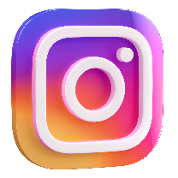Sections in Component based design approach:

Identity:

* Icon
* Colors: purple-pink, white, black
* Font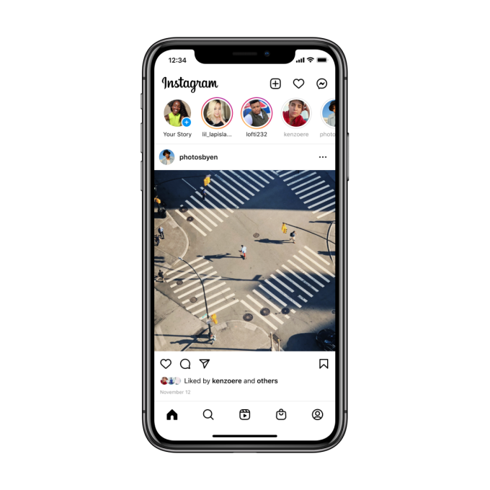

Composition:

* List of stories

Components:

* input and comment preview!
* liking, sharing

UI Elements:

* follow button
* heart, comment, send, book mark
* input : search bar, comment box
* text: username, timestamps

Layout:

* Story tray - horizontal stacked.
* Posts - vertically stacked.

Page: Final UI screens from layouts and composition feed layout , Fullscreen video player layout